# Backup Policy

COVID 19 Vaccination database is required to be always accessed during the day so having automatic full and differential backups at off peak times is a must. Also, nobody wants to be doing backups every day or week so setting them up automatically will save cost and time.

## Full Backups

Because full backups take a lot more storage space than other backup methods, I’m recommending that once a week a fullback is done to the database.

Every Sunday at 3am a Full back will take place.

## Partial/Differential Backups

Partial/Differential backups use a lot less storage space as they are only backup data that has changed since the last backup. So doing this backup daily would be beneficial.

Every Day except Sunday at 4am partial/ differential backup will take place.

## Transaction Log Backups

Because the database can’t lose more than 15 minutes worth of work the transaction log backup frequency will be every 15 minutes from 7am till 7pm every day.

## Replication

Asynchronous replication in real time to lower the risk of data loss.

# Task Scheduler Screenshots

## Full backup

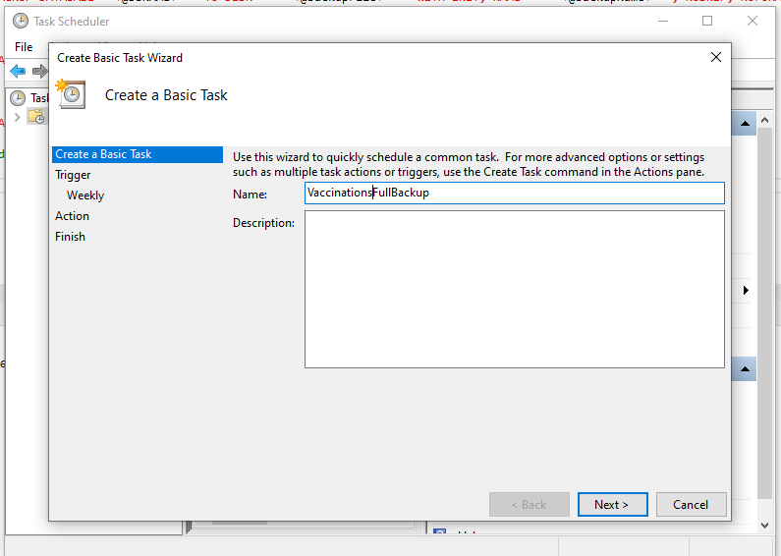

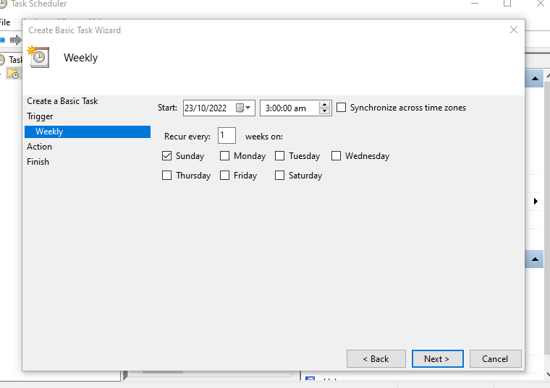

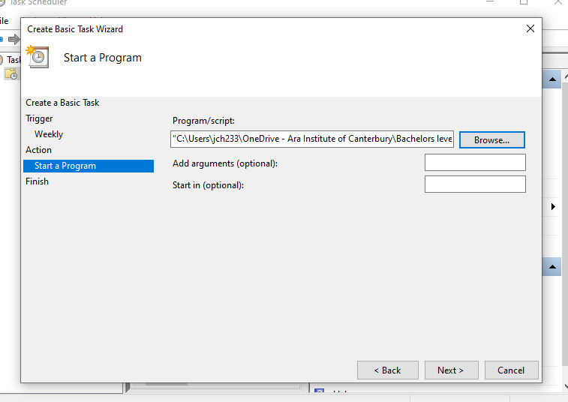

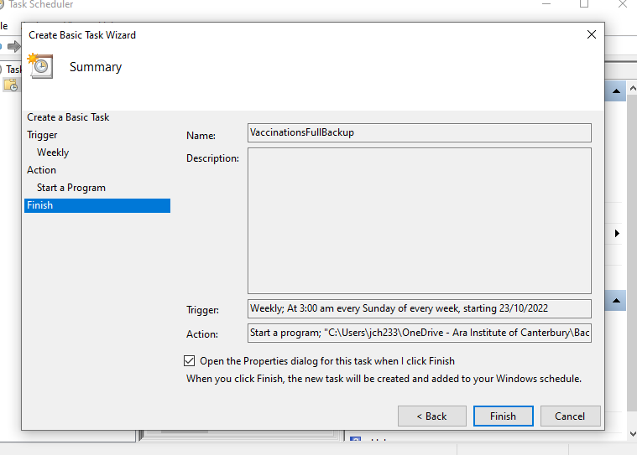

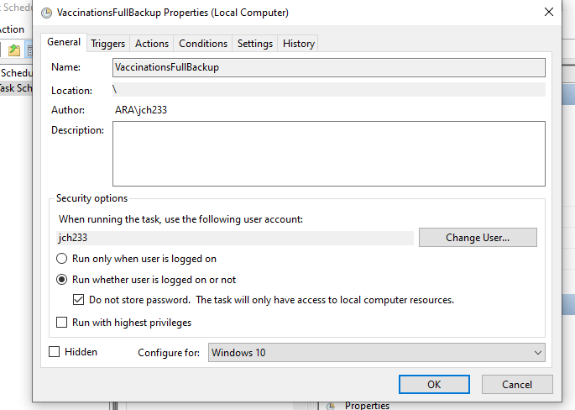

## Differential backup

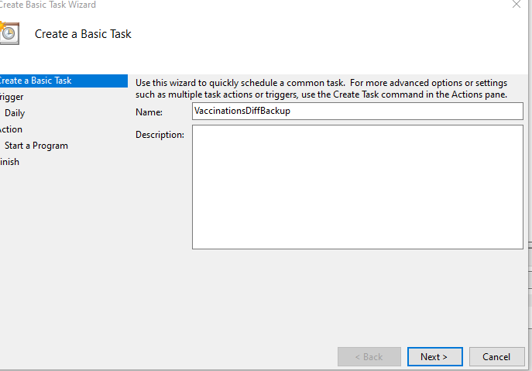

## Transaction Log backup

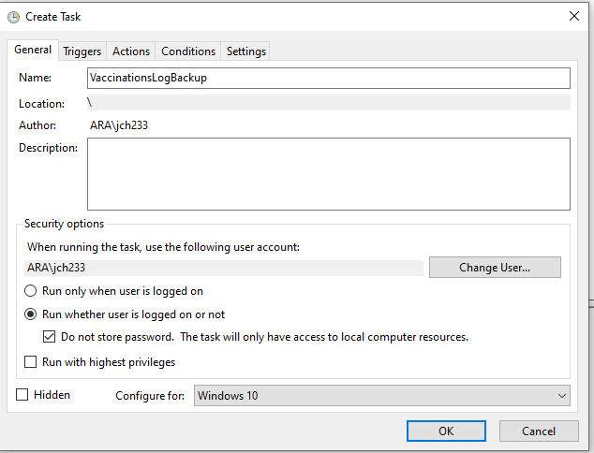

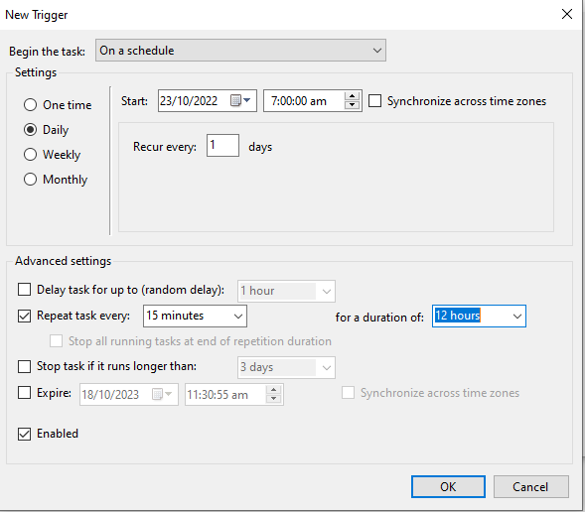

## Tasks Scheduled

